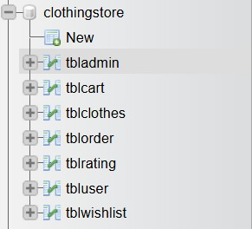
- tblUser

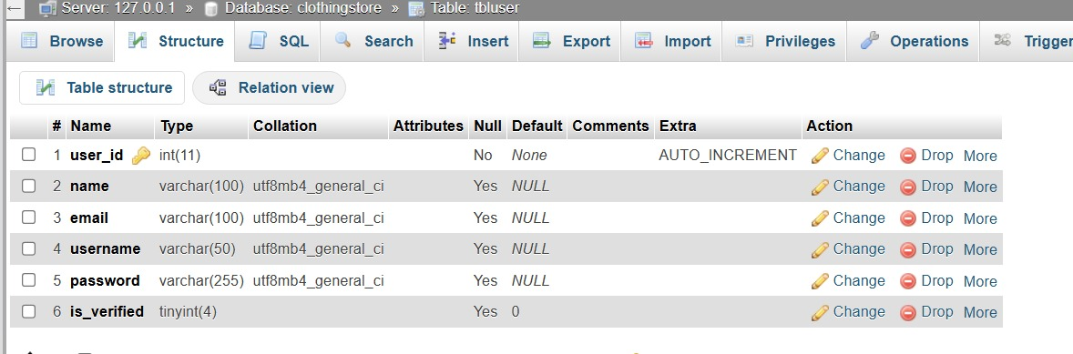
Fields:
- user_id – INT (Primary Key, Auto Increment)
- name – VARCHAR(100)
- email – VARCHAR(100)
- username – VARCHAR(50)
- password – VARCHAR(255)
- is_verified – TINYINT
Description:
The tblUser table stores all registered users of the Pastimes web application. Each user has personal information, login credentials, and verification status.
Purpose:
This table allows customers to register, log in, and access the clothing marketplace after administrator approval.
Relationships:
- user_id is referenced by tblClothes(seller_id)
- user_id is referenced by tblCart(user_id)
- user_id is referenced by tblWishlist(user_id)
- user_id is referenced by tblOrder(user_id)
This ensures users can own products, add items to carts, create wishlists, and place orders.

- tblAdmin
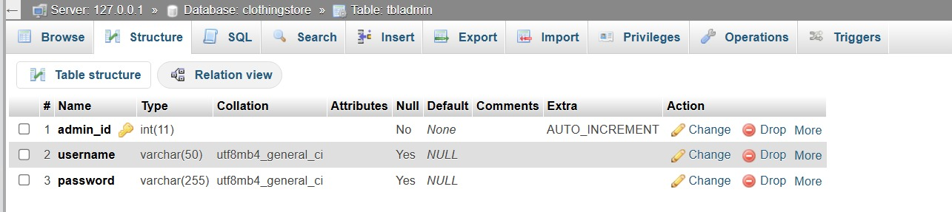

Fields:
- admin_id – INT (Primary Key, Auto Increment)
- username – VARCHAR(50)
- password – VARCHAR(255)
Description:
The tblAdmin table stores administrator login details for the Pastimes system.
Purpose:
This table allows administrators to access the admin dashboard and verify newly registered customers.
Relationships:
This table operates independently and manages administrative access to the system.

- tblClothes

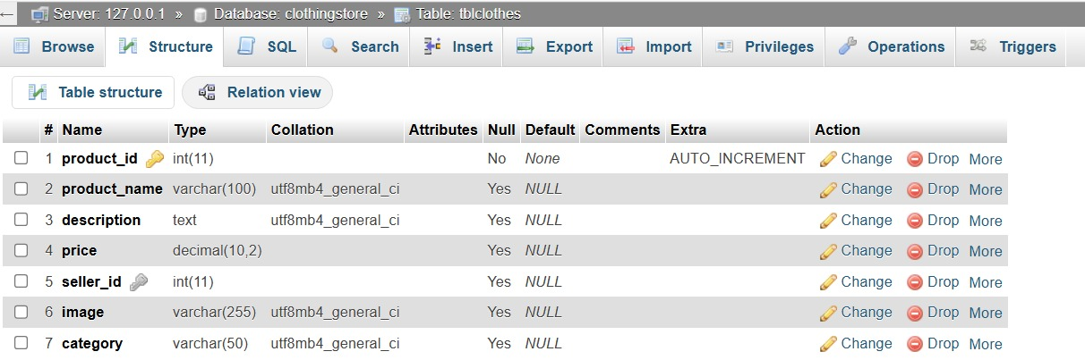
Fields:
- product_id – INT (Primary Key, Auto Increment)
- product_name – VARCHAR(100)
- description – TEXT
- price – DECIMAL(10,2)
- seller_id – INT (Foreign Key)
- image – VARCHAR(255)
- category – VARCHAR(50)
Description:
The tblClothes table stores all clothing products uploaded by sellers.
Purpose:
This table allows users to sell second-hand luxury clothing products on the platform.
Relationships:
- seller_id references tblUser(user_id)
This ensures every product belongs to a registered seller.

- tblCart
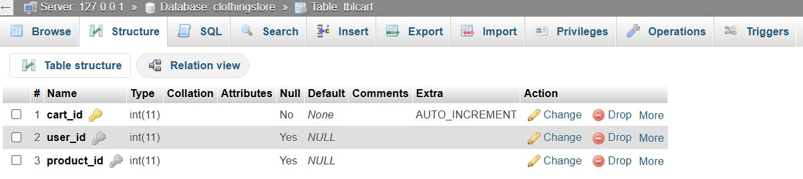
Fields:
- cart_id – INT (Primary Key, Auto Increment)
- user_id – INT (Foreign Key)
- product_id – INT (Foreign Key)
Description:
The tblCart table stores products added to a customer’s shopping cart.
Purpose:
This table allows users to collect products before checkout.
Relationships:
- user_id references tblUser(user_id)
- product_id references tblClothes(product_id)
This ensures cart items belong to valid users and products.

- tblWishlist
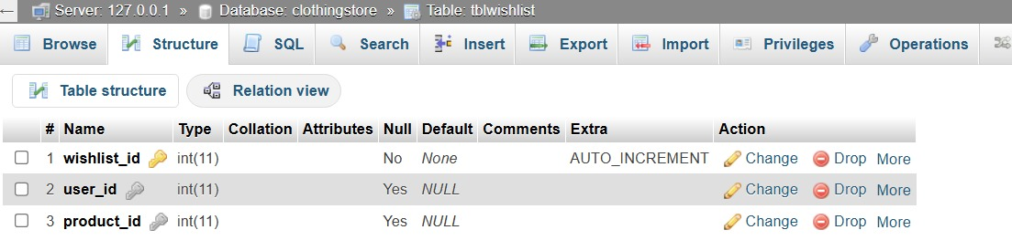
Fields:
- wishlist_id – INT (Primary Key, Auto Increment)
- user_id – INT (Foreign Key)
- product_id – INT (Foreign Key)
Description:
The tblWishlist table stores products that users save for later.
Purpose:
This table allows customers to bookmark products they may want to purchase later.
Relationships:
- user_id references tblUser(user_id)
- product_id references tblClothes(product_id)
This ensures wishlist items belong to valid users and products.

- tblRating
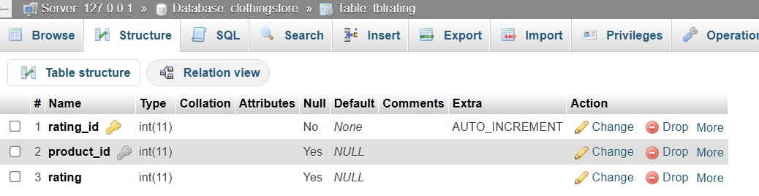
Fields:
- rating_id – INT (Primary Key, Auto Increment)
- product_id – INT (Foreign Key)
- rating – INT
Description:
The tblRating table stores customer ratings for clothing products.
Purpose:
This table allows users to rate products and helps build trust in the marketplace.
Relationships:
- product_id references tblClothes(product_id)
This ensures ratings are linked to valid products.

- tblOrder
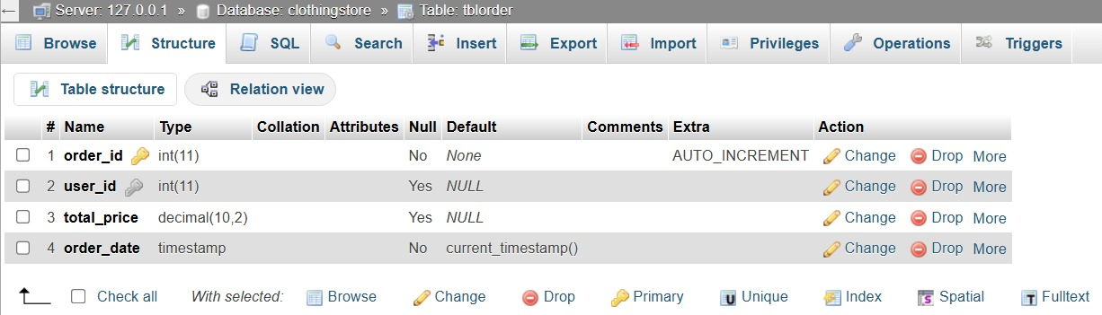
Fields:
- order_id – INT (Primary Key, Auto Increment)
- user_id – INT (Foreign Key)
- total_price – DECIMAL(10,2)
- order_date – TIMESTAMP
Description:
The tblOrder table stores completed customer purchases.
Purpose:
This table keeps track of customer orders, total payments, and purchase dates.
Relationships:
- user_id references tblUser(user_id)
This ensures orders are linked to valid customers.

